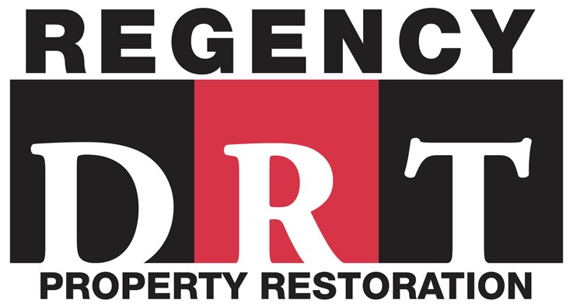

AFTER THE DISASTER
THE FIRST 24 HOURS
Insurance companies play an important role in protecting individuals from a total loss when catastrophe strikes. However, in the chaos following a fire or water disaster, insurance policies can be confusing and easily misinterpreted. Despite all the turmoil and confusion, it is critical to make wise and educated decisions becuase you will be living with the results long after the confusion has passed and the disaster has been resolved. Your insurance policy entitles you to certain rights and certain obligations. As professional restoration contractors, we believe that it is in your best interest to understand tha rights and options available to you.
The Restoration Industry Association (RIA) has completed a list of 12 questions frequently asked by policyholders.

What action does my insurance policy require after a loss?  In addition to notifying your insurance carrier, most policies require that you take reasonable action to protect your property from further damage. If you fail to do so, your insurance may not cover any additional loss caused by your failure to provide such protection.  If I have obtained adequate coverage, what should my insurance pay for?  After a covered loss you are entitled to be paid the fair cost of restoring your home to its pre-damaged condition, minus your deductible. However, you should not expect to be paid for the repair of unrelated problems such as deterioration, pre-existing damage, or code deficiencies.  Must I hire a restoration company recommended by my insurance company?  Your insurance policy does not state that you must retain a restoration company that is referred or approved by the insurance company. You are entitled to employ the services of a reputable, full licensed, and insured repair firm. |  | Am I required to use the restoration company with the lowest price?  You are not required to accept the lowest bidder. Repair rates should correspond to prevailing standards in your area for work of professional quality, amd you may not be forced to use the “cheapest” or “lowest price” bid.  Can my insurance company hire a repair firm to work on my house?  Only the owner of the property can authorize a company to perform work on that property. The repair contract is between the owner and the contractor. Your insurer does not have the right to directly contract for your repairs or insist that you employ a particular restoration firm.  What quality of materials and workmanship am I entitled to receive?  Your insurance policy should pay for materials and workmanship that are equal to the kind and quality of your existing ones. After repairs, the property should suffer no loss in value as a result of the damage. However, the insurance company is not obligated to improve your existing installation.
NOTE: This information is distributed for educational purposes only and is not intended to and should not be construed as providing legal advice.

How do disclosure rules affect my repairs? Under current laws you may have to disclose past damage to any future buyers, making it essential that all evidence of damage be completely eliminated. Damage that has been covered up may be discovered later and raise serious problems for the prior owner.  What should my contract include?  You are entitled to receive a detailed listing of repairs, as well as the quantities and types of materials to be used before work begins. The specifications should be a part of your contract. Don’t accept thumbnail or “repair as necessary” specifications. The possibility of hidden damage or additional charges should be fully described at the outset.  Is a special license required for insurance repairs?  States have differing licensing requirements for home repairs. There are also local regulations and home improvement laws to be considered. Federal regulations also may apply to home repairs, such as recission notices and special requirements for asbestos, lead, and bloodborne pathogens. You are entitled to reject any contractor not in compliance with all federal, state, and local requirements for residential construction. |  | How can I evaluate a restoration contractor? First, ask for references to three jobs the contractor is currently working on or has recently completed. Call them. Second, check with your local Better  Business Bureau for any unresolved complaints. Third, ask the contractor for credentials and association memberships that idicate professional training and status in insurance repair and restoration, since this differs from ordinary home improvement or maintenance.  What if the insurance company and I cannot agree on the amount of the loss?  If disagreement arises between you and the insurance company over the amount of the loss, you are entitled to request arbitration (“appraisal”) as described in your policy. The standard homeowner’s policy spells out the procedures for appraisal without resorting to a lawsuit. The insurance company may also request appraisal.  How long must I wait for my insurance payment?  You are entitled to receive payment from the insurance company within the time specified by the policy and your state insurance regulations. Usually this is 30 to 60 days after submittal of the signed proof of loss. However, the policy also has time requirements for the policyholder. Check your policy or ask your adjuster or agent about them so that you will know what to expect.
 | Checklist of things to do immediately following a fire or flood:
• | Get your family some place safe and secure.
• | Contact the American Red Cross - www.redcross.org or your local chapter - they can supply temporary housing, clothing, food, medications, etc.
• | Do not re-enter the building until declared safe by an emergency management official.
• | When able to enter the premises, remove valuables such as jewelry, medication (for replacement purposes only), clothing, and important papers. Do not remove food or cosmetics.
• | Secure the building to prevent further damage from weather or vandalism - e.g., screw plywood over windows, place tarps over open roof areas.
• | Contact your insurance company.
• | Select a service provider. Be sure to check references.
• | Get a notebook to record dates and times of conversations and individuals you speak with concerning your claim.
• | Save all receipts for meals, hotels, toiletries, replacement clothing, etc.

